Patient Legal Name: ______ Date of Birth:
Patient Phone Number:
Procedure Name & CPT Code(s):
Diagnosis & ICD-10 Code(s):
Special Equipment Needs: ____________________________________________________________________
Documents Attached (check all that apply):
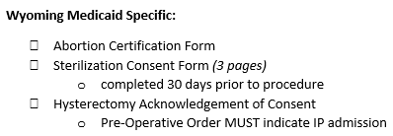
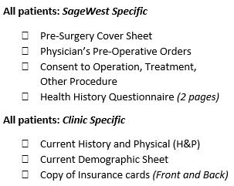

__________________________________________________________________________________________________
Insurance Verification:
Primary: Secondary:
Phone#: Phone#:
ID#: ID#:
Date Verified: Date Verified: _________
AUTH#: AUTH#:
Inpatient # Days Approved: __________________ Inpatient # Days Approved: ________________________
Ins. Representative Name: ____________ Ins. Representative Name: ______
Call Reference #:____________________________ Call Reference #: _________________________________
FAX ALL DOCUMENTS (including this completed page) TO: 307-204-8804
Updated 08/2022

